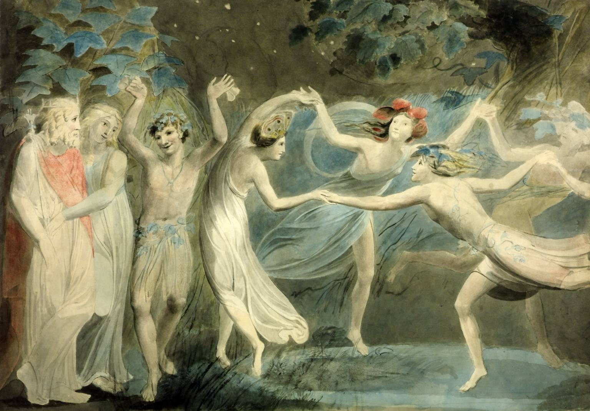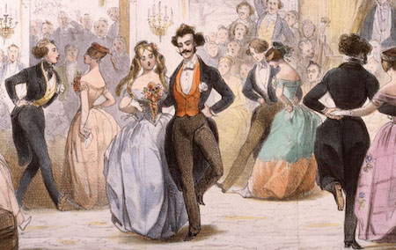

**Santa Cruz Social Dance Convocation**

***DanCE Party!***

**August 26, Saturday 7 – 10 p.m. @ Market St Senior Center**

**222 Market St. Santa Cruz** (x/Water Street near Ocean St.)

DJ music with

Waltz, Salsa Rueda, Swing, West Coast Swing, Tango, Line dances

& more, with mini-intro lessons

We rotate partners so come solo or with friends. Dress comfortably and classy.

**Tickets:**

**In Advance** $8/General $12/couple $6/student, senior(age 65+)

**@ Door --** $12/General $18/couple $7/student, senior(age 65+)

**Purchase Advance tickets from the following sponsors**

**Santa Cruz Waltz**

**Salsa Rueda**

**Sunday Waltz with Bob Folker**

**(and others)**

*look for future Convocation events too!*

**www. PeggyDance.weebly.com**

